**Export API Scan Results to Tosca to Automate TestCases**

* Export API Scan Results into tosca commander, so that we can create automated testcases

**Tosca Export: 🡪**

* Every Message that you exported from API Scan to Tosca Commander will be turned into Two modules & Two Teststeps
* Each Module & Teststep represents either a Request or Response Part of the message to allow tosca to Automate & Test the API and set Dynamic Parameters
* Modules contain the technical information of SUT (Coffee Shop)

Once we create our coffee shop using POST and GET methods, we need to export this 2 methods 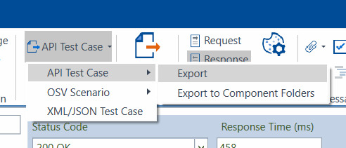

1. Create a new component folder in Tosca commander

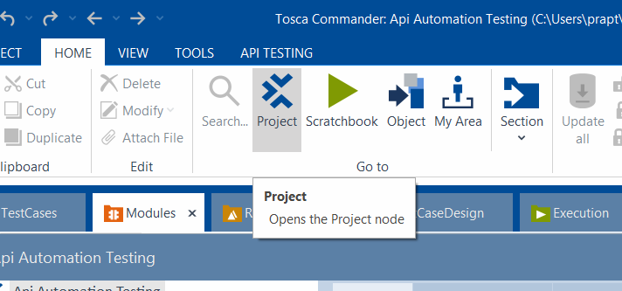

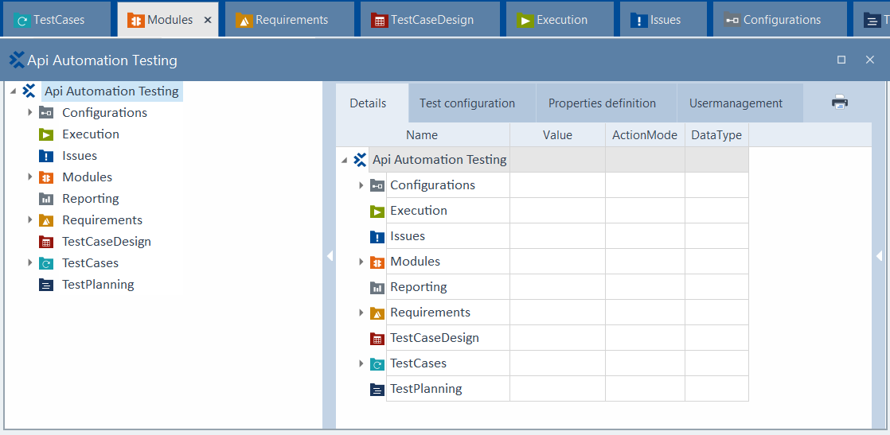

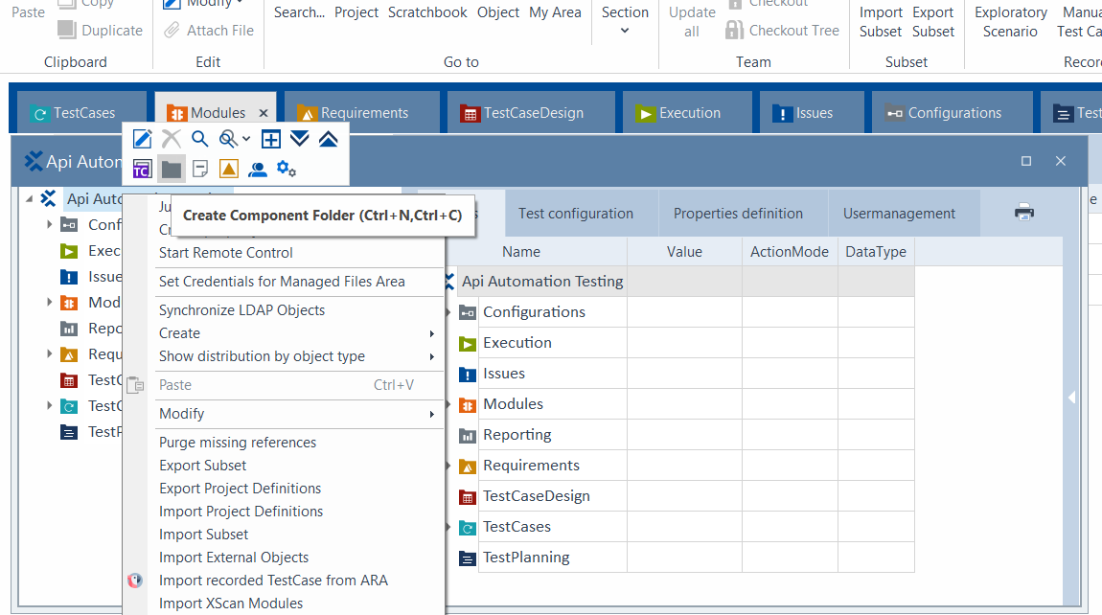

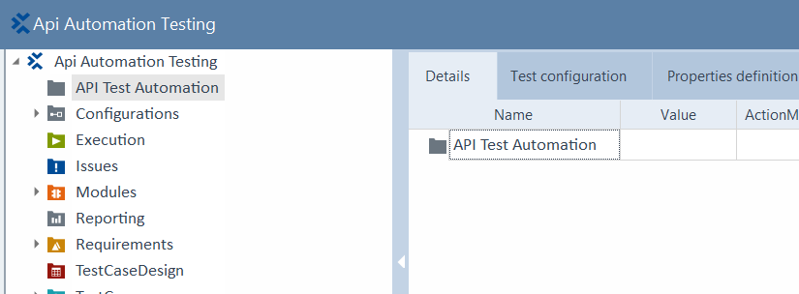

* This is required to export or import API scan results to the folder
* Before Exporting scan results to Tosca, we need to create a component folder

1. Select the message to export into tosca

* To select multiple operations in API Scan use “Ctrl” key

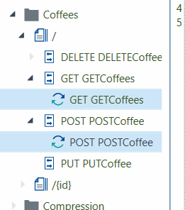

1. Select Get, Post messages in Shop Folders
2. Messages can be exported by clicking option API testcase in ribbon
3. By default, component folder will be called APIScan_Import. You can rename so that it is easier to identify
4. Start Automating API testcase

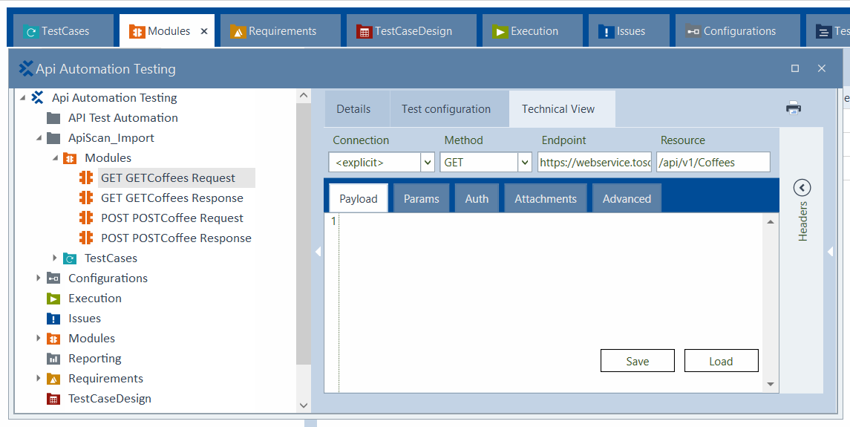

* Four modules and 2 Testcases are created